Fingerprint-Based Blood Group Detection Using Deep Learning and Image Processing

Raji V  
*Department of Information Technology  
SKP Engineering College*Tamil Nadu, India  
raji.vpm@gmail.com

Sankaran L  
*Department of Information Technology  
SKP Engineering College*Tamil Nadu, India  
saran.sankaranl@gmail.com Parasuram T  
*Department of Information Technology  
SKP Engineering College*Tamil Nadu, India  
tspsparasuram@gmail.com

Samhitha M  
*Department of Information Technology  
SKP Engineering College*Tamil Nadu, India  
samhitha.muthu@gmail.com Parasuraman K  
*Department of Information Technology  
SKP Engineering College*Tamil Nadu, India  
parasupattu0405@gmail.com

*Abstract*— Blood group prediction plays a vital role in medical diagnostics and emergency care. Traditional serological methods, while accurate, require blood samples, specialized laboratory equipment, and time-consuming procedures, making them impractical in resource-limited or urgent situations. This research explores a novel, non-invasive approach to blood group detection using fingerprint images and deep learning techniques. Specifically, we employ Convolutional Neural Networks (CNNs) to analyze fingerprint patterns and establish correlations with blood groups. By leveraging advanced deep learning architectures, this study aims to provide a faster, efficient, and accessible alternative to conventional methods. The proposed approach not only enhances the speed and convenience of blood group identification but also reduces dependency on laboratory facilities. The feasibility of this technique is examined through extensive experimentation, offering insights into its potential for real-world medical applications.

Keywords— Blood typing, Fingerprint analysis, Deep learning, Convolutional Neural Networks (CNN), Image processing, Biometrics.

# I . Introduction

Fingerprints are basic biometric features that uniquely identify individuals based on the complex patterns formed by the grooves and valleys on the fingertip. These patterns are formed during fetal life and do not change throughout life, making them a reliable means of identification. The primary fingerprint patterns are divided into three main types: loop, whorl, and arch. The most common pattern, the loop, forms a curved edge that rotates on itself and can be categorized into radial loops (opening towards the thumb) and ulnar loops (opening towards the pinky finger). These account for 60-70% of all fingerprints. Whorl patterns are found in approximately 25-35% of fingerprints and are characterized by the formation of a circular or spiral edge. The least common pattern, the arch, is found in only 5% of fingerprints. An arch is a wavy structure in which grooves run from one side of the finger to the other without bending.

In addition to these basic classifications, fingerprints also have small points such as forks, groove ends, islands, and enclosures that add further uniqueness to each fingerprint. These intricate details make fingerprints invaluable for personal identification and security applications. However, recent research suggests that fingerprint patterns may also contain subtle biological information, such as correlations with blood types.

Blood sorts are decided by the nearness or nonappearance of certain antigens on the surface of ruddy blood cells. The main blood types are A, B, AB, and O, and each type is further classified as positive or negative by the Rh factor. Accurate determination of blood type is crucial in medicine, especially in blood transfusions, organ transplants, and the treatment of hemolytic diseases.

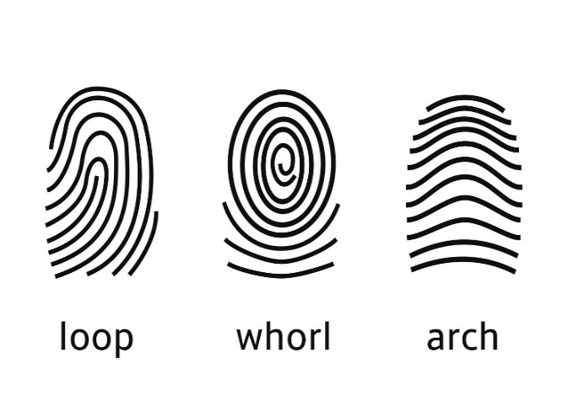

Fig1: Different types of fingerprint patterns

Traditionally, blood types have been identified using serological methods, in which a blood sample is mixed with certain antibodies and a reaction is observed. These methods are highly accurate, but are invasive and require blood samples and laboratory facilities, which are not always available, especially in emergency situations or when resources are limited. The concept of fingerprint-based blood typing is an innovative, non-invasive alternative that could revolutionize blood typing.

In this study, we investigate the possibility of using deep learning techniques, specifically Convolutional Neural Networks (CNNs), to analyze fingerprints and predict blood types. CNNs are well suited for image-based classification tasks, as they efficiently capture spatial patterns and extract meaningful features. This study aims to evaluate the effectiveness and accuracy of leveraging CNN architectures, including LeNet-5, AlexNet, VGG16, and ResNet-34, in classifying blood types based on fingerprint patterns. The results of this study could pave the way for rapid, non-invasive blood typing, with potential applications in medical, emergency care, and forensic investigations.

# LITERATURE REVIEW

T. Nihar et al. proposed a method for blood group determination using fingerprint images, employing Convolutional Neural Networks (CNNs) like LeNet and AlexNet for fingerprint classification. Their approach involved ridge frequency assessment and Gabor filters for feature extraction. While the study did not specify accuracy, it highlighted the potential of non-invasive blood typing in healthcare and forensic applications. Future research aims to expand dataset sizes and incorporate additional fingerprint features to improve precision [1].

Vijaykumar, Patil N., and D. R. Ingle introduced a novel approach for predicting blood groups using fingerprint map reading. Their research applied ridge frequency estimation and Gabor filters to extract spatial fingerprint features. The study utilized Multiple Linear Regression with Ordinary Least Squares (OLS) for blood group prediction, achieving an accuracy of 62% [2].

Swathi P et al. conducted a study on fingerprint-based blood group prediction using deep learning, employing CNN models trained on intricate fingerprint image features. The model aimed to identify patterns correlated with blood groups, achieving an accuracy of 62% [3].

Amit Patil et al. investigated the relationship between fingerprint patterns, gender, and blood groups. Their study, conducted in Navi Mumbai, analyzed 170 subjects (100 females, 70 males) aged 18-65 years. Using Henry’s classification system, fingerprints were categorized into loops (62.35%), whorls (32.94%), and arches (4.7%). Statistical Chi-square tests revealed a significant association between fingerprint patterns and ABO blood groups (p < 0.05), but no correlation with gender or Rh factor. This study suggests potential forensic applications for predicting ABO blood groups from fingerprint patterns [4].

Harem Othman Smail et al. studied 450 university students to examine fingerprint pattern distributions across ABO and Rh blood types. They found loops (49.62%), whorls (42.48%), and arches (7.88%) as the most common patterns. Using Chi-square tests, they identified significant correlations between fingerprint patterns and blood groups A, B, and AB (p < 0.05), though no correlation was found for blood group O. Their findings further support the hypothesis that certain biometric features can aid in blood group prediction [5].

Despite existing research, deep learning-based models have not been extensively explored for blood group detection. Previous studies relied on statistical methods or traditional machine learning models, which often lack the generalization capability of CNNs. This project enhances accuracy by leveraging ResNet34, which is known for its strong feature extraction capabilities and residual learning. By applying deep learning and image processing, this research aims to develop a more robust, scalable, and accurate model for non-invasive blood group detection.

# METHODOLOGY

*Existing Methodology:*

Blood group detection in the current healthcare system is primarily conducted through traditional serological methods. These methods identify blood groups based on antigen-antibody interactions. The key existing techniques include.

## Serological Testing

ABO and Rh Typing: A blood sample is mixed with anti-A, anti-B, and anti-Rh antibodies. Agglutination (clumping) indicates the presence of A, B, or Rh antigens, classifying blood into one of eight types (A+, A-, B+, B-, AB+, AB-, O+, O-).

Cross-Matching: Before blood transfusions, donor and recipient blood samples are mixed to test for compatibility and prevent adverse reactions.

## Automated Blood Typing Systems

Automated Analyzers: These machines automate blood typing by mixing blood with reagents, analyzing results using optical sensors, and providing accurate blood group identification.

Widely Used In: Hospitals, blood banks, and diagnostic laboratories for rapid testing.

## Genotyping (DNA-Based Methods)

Genetic Analysis: Determines blood groups by identifying genes responsible for blood group antigen expression.

Advantages: Highly accurate.

Limitations: High cost and complexity make it unsuitable for routine testing.

*Proposed Methodology*

The proposed system aims to develop a non-invasive blood group detection method using fingerprint images and deep learning models. The key steps include data collection, preprocessing, feature extraction, CNN model training, and prediction.

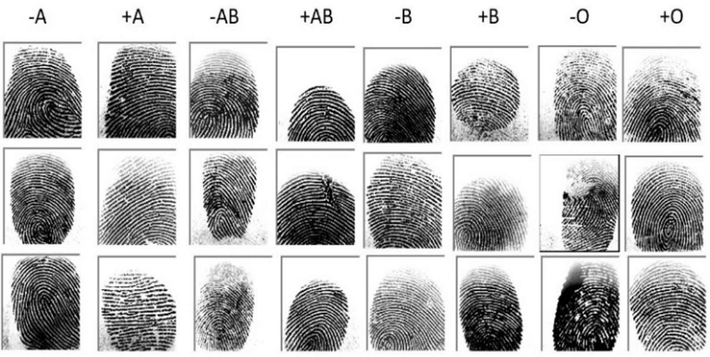

Fig 2: Dataset of fingerprints of different blood groups

## Data Collection

* A dataset of 6,000 fingerprint images was collected from friends, students, and online sources (e.g., Kaggle).
* Each image was labeled with one of the eight blood groups: A+, A-, B+, B-, AB+, AB-, O+, O-.
* A diverse set of fingerprints was gathered to ensure balanced representation and avoid bias.

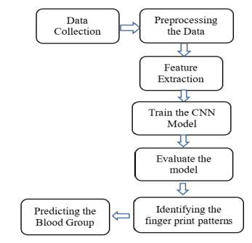

Fig 3: Blood group prediction with finger print images framework

*B. Preprocessing the Data*

* To enhance fingerprint image quality for better model accuracy, the following techniques were applied:
* Grayscale Conversion: Reduces image complexity.
* Normalization: Pixel values scaled between 0 and 1 for consistency.
* Noise Removal: Applied Gaussian filtering to remove unwanted artifacts.
* Contrast Adjustment: Enhances fingerprint ridges for clear identification.
* Resizing: Images resized to match the input size required by CNN models.

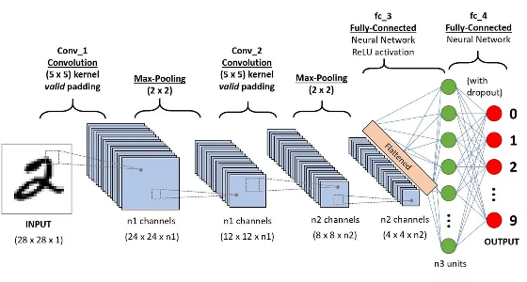

Fig 4: Convolutional neural network process

*C. Feature Extraction*

* Convolutional Neural Networks (CNNs) automatically extract key fingerprint patterns.
* Initial CNN layers detect edges, ridges, and textures.
* Deeper CNN layers recognize complex structures unique to each blood group.
* Pooling layers down sample images, reducing computational cost while preserving essential features.

*D. Training the CNN Model*

* The dataset was part into preparing (70%), approval (15%), and testing (15%) sets.
* Multiple CNN architectures were tested, including:
  + LeNet-5
  + AlexNet
  + ResNet-34
  + VGG16
* Each model was trained using categorical cross-entropy loss and optimized using Adam optimizer.

*E. Model Evaluation*

* Execution was assessed utilizing measurements like precision, exactness, review, and F1-score.
* Validation loss and accuracy were monitored to prevent overfitting.
* The best-performing model was selected for real-time blood group prediction.

*F. Identifying Fingerprint Patterns*

* The trained CNN model analyzed fingerprint patterns to identify unique ridge formations linked to blood groups.
* Features such as ridge density, bifurcations, and minutiae points were correlated with different blood groups.

*G. Predicting the Blood Group*

* Users upload a fingerprint image, and the trained CNN model classifies it into one of the eight blood groups (A+, A-, B+, B-, AB+, AB-, O+, O-).
* The system provides real-time and non-invasive blood group detection results.

Proposed Learning Algorithm

1. Input**:** Fingerprint image (m × n pixels).
2. ResNet Block:
   1. Two convolutional layers extract fingerprint patterns.
   2. Batch normalization ensures stable training.
   3. Skip connections improve gradient flow in deep networks.
   4. ReLU activation function introduces non-linearity.
3. Model Architecture:
   1. Input Layer: Fingerprint image.
   2. Initial Convolution: Detects basic structures.
   3. Max Pooling: Reduces image size while preserving features.
   4. Residual Blocks: Enhance feature extraction.
   5. Global Average Pooling: Reduces overfitting.
   6. Output Layer: Softmax activation classifies the blood group.
4. Compilation & Training:
   1. Loss Function: Categorical cross-entropy.
   2. Optimizer: Adam / SGD.
   3. Training: Performed on the fingerprint dataset.
5. Output**:** Predicted blood group (A+, A-, B+, B-, AB+, AB-, O+, O-).

# RESULTS AND DISCUSSION

To evaluate the performance of deep learning models for fingerprint-based blood group detection, we trained LeNet-5, VGG-16, ResNet-34, and AlexNet for 20 epochs and analyzed key performance metrics such as accuracy, loss, validation accuracy, and validation loss. These metrics are critical in assessing how well a model learns from training data and generalizes to unseen data.

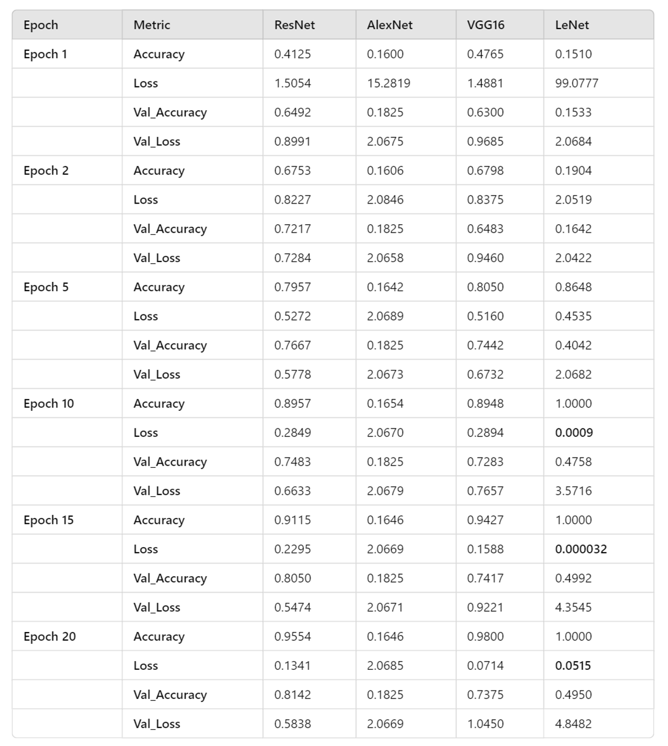

* Accuracy measures the proportion of correctly classified samples in the dataset. A higher accuracy means the model effectively distinguishes between different blood groups.
* Loss represents the error between predicted and actual values. A lower loss value suggests the model is learning effectively.
* Validation Accuracy evaluates how well the model performs on new, unseen data. A high validation accuracy indicates better generalization.
* Validation Loss indicates how well the model maintains its learning on unseen data. A lower value suggests the model is not overfitting.

To determine the best model for fingerprint-based blood group classification, we compare the four models based on these key metrics.

## LeNet-5 Performance

* + Training Accuracy: 100%
  + Validation Accuracy: 49.50%
  + Training Loss: Extremely low
  + Validation Loss: 4.8482

Analysis**:**

LeNet-5 achieved perfect training accuracy (100%), indicating that it memorized the training dataset entirely. However, this resulted in poor validation performance, with validation accuracy dropping to 49.50% and validation loss increasing to 4.8482.

This clearly suggests that LeNet-5 suffered from severe overfitting. The model performed well on the training dataset but failed to generalize to unseen fingerprint images, making it unreliable for real-world applications. Overfitting occurs when a model learns training data patterns too precisely, leading to poor generalization on new data.

Although LeNet-5 is a simple and efficient architecture for basic image classification, it lacks the depth needed to capture complex fingerprint patterns for blood group classification.

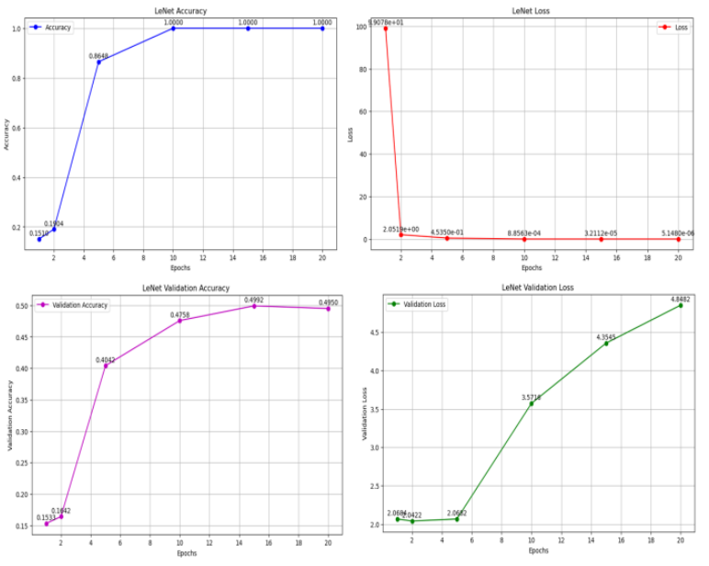

Fig 6: Performance graph of LeNet-5

## VGG-16 Performance

* + Training Accuracy: 98.00%
  + Validation Accuracy: 73.75%
  + Training Loss: Moderate
  + Validation Loss: 1.0450

#### Analysis:

VGG-16 demonstrated high training accuracy (98.00%) and moderate validation accuracy (73.75%), making it one of the better-performing models. The validation loss (1.0450) was significantly lower than LeNet-5, showing that it generalized better to unseen data.

However, despite its higher validation accuracy, VGG-16 still showed signs of overfitting. The difference between training and validation accuracy suggests that while the model learned the patterns in the training set effectively, it struggled with completely generalizing to new fingerprint images.

This overfitting issue, though less severe than in LeNet-5, indicates that VGG-16 might not be the optimal model for fingerprint-based blood group detection.

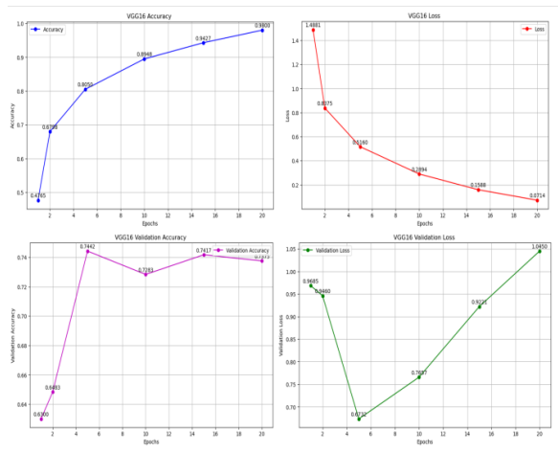

Fig 7: Performance graph of VGG 16

## ResNet-34 Performance

* Training Accuracy: 95.54%
* Validation Accuracy: 81.42%
* Training Loss: Balanced
* Validation Loss: 0.5838

#### Analysis:

#### ResNet-34 outperformed all other models by maintaining a strong balance between training and validation performance. While its training accuracy (95.54%) was slightly lower than that of VGG-16 and LeNet-5, its higher validation accuracy (81.42%) and lower validation loss (0.5838) indicated superior generalization.

#### One of the key strengths of ResNet-34 is its skip connection architecture, which prevents vanishing gradients and allows the model to capture intricate patterns in fingerprint images. Unlike LeNet-5 and VGG-16, which showed varying degrees of overfitting, ResNet-34 generalized well to new fingerprint images, making it the most reliable model for real-world deployment.

#### The low validation loss (0.5838) further confirms that ResNet-34 learned robust features without excessive memorization, ensuring stable predictions on unseen data.

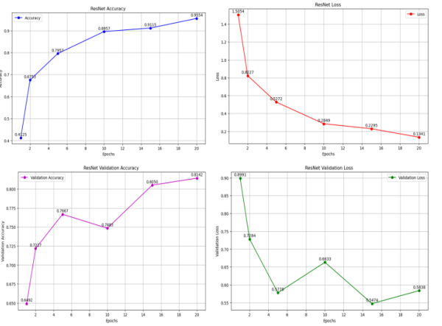

Fig 8: Performance graph of ResNet-34

## AlexNet Performance

#### Training Accuracy: 16.46%

#### Validation Accuracy: 18.25%

#### Training Loss: High

#### Validation Loss: High

#### Analysis:

#### AlexNet showed the worst performance among all models, with very low training accuracy (16.46%) and validation accuracy (18.25%). The high loss values indicate that the model struggled to learn meaningful features from fingerprint images.

#### This poor performance suggests that AlexNet’s architecture is not well-suited for complex tasks like fingerprint-based blood group detection. The model failed to extract significant patterns from the dataset, leading to inaccurate predictions. Due to its poor learning capability, AlexNet was deemed ineffective for this application.

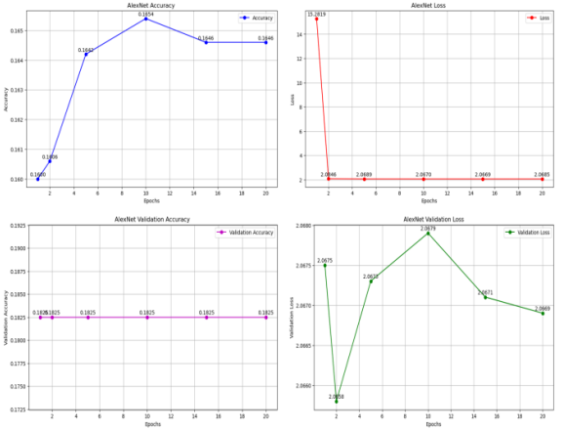

Fig 9: Performance graph of AlexNet

#### Comparative Model Analysis:

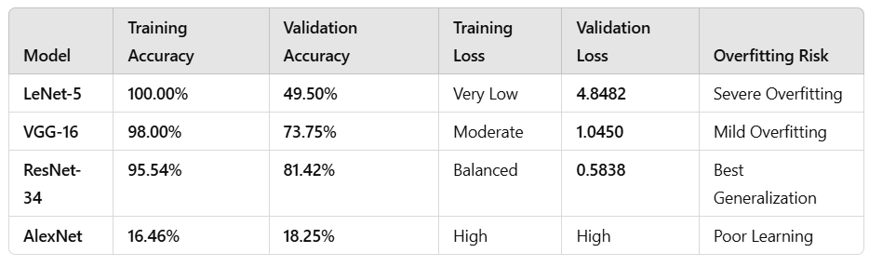

Key Observations:

* ResNet-34 achieved the best validation accuracy (81.42%) and lowest validation loss (0.5838), proving its ability to generalize well.
* VGG-16 performed well but showed signs of overfitting in later epochs.
* LeNet-5 memorized the training data perfectly (100% accuracy) but failed to generalize, leading to poor validation performance.
* AlexNet performed the worst, failing to learn meaningful patterns from fingerprint images.

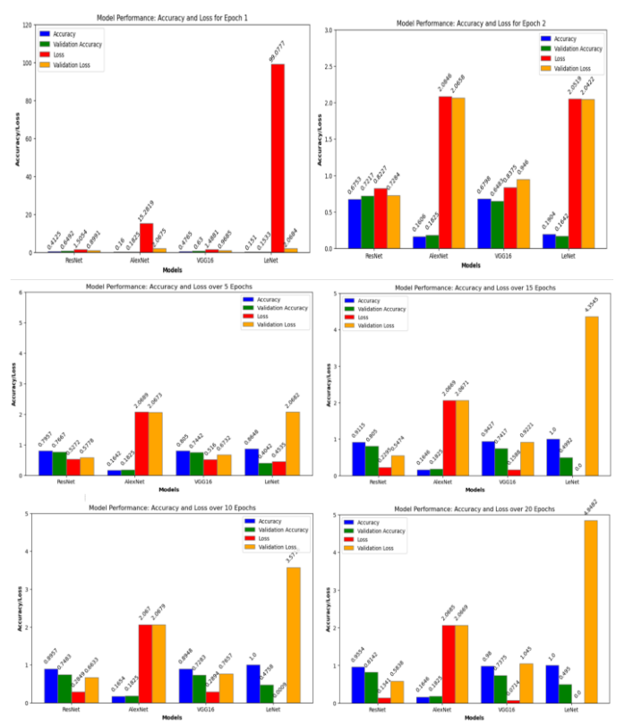

Fig 10: Overall Performance of Models

Final Model Selection

Based on our comparative analysis, ResNet-34 was identified as the most suitable model for fingerprint-based blood group detection due to its ability to maintain high accuracy while minimizing overfitting.

Advantages of ResNet-34:

* High Validation Accuracy (81.42%) → Reliable performance on unseen data
* Low Validation Loss (0.5838) → Strong generalization ability
* Skip Connections → Prevent vanishing gradient problems
* Balanced Performance → Avoids overfitting

Limitations of Other Models:

* LeNet-5 Overfitted Severely (100% training accuracy but only 49.50% validation accuracy)
* VGG-16 Showed Some Overfitting (Good performance but slightly unstable validation results)
* AlexNet Struggled to Learn (Failed to extract relevant fingerprint features)

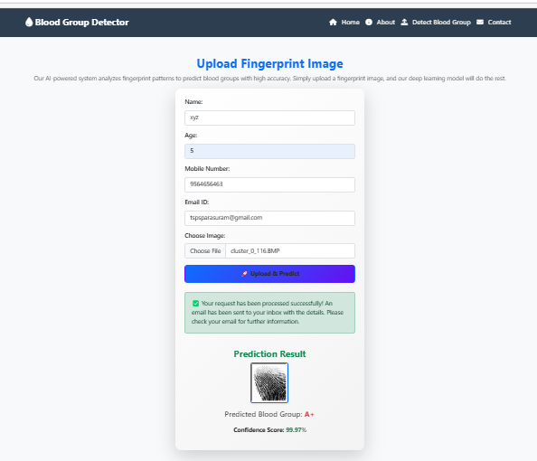

Fig 11: Test result of predicting blood of finger print image

# CONCLUSION & FUTURE SCOPE

This study evaluated four CNN architectures—LeNet-5, AlexNet, VGG-16, and ResNet-34—for fingerprint-based blood group detection. ResNet-34 emerged as the best-performing model, achieving 95.54% training accuracy and 81.42% validation accuracy, due to its deeper architecture and residual connections. While LeNet-5 and VGG-16 showed signs of overfitting, AlexNet performed poorly.

Challenges such as dataset limitations and fingerprint variations highlight the need for further research. Future work can integrate biometric and genetic data, explore advanced deep learning models, and validate with larger datasets. Developing real-time applications could make fingerprint-based blood group detection a practical and accessible medical tool.

##### References

1. T. Nihar, K. Yeswanth, and K. Prabhakar, “Blood group determination using fingerprint,” MATEC Web of Conferences, vol. 392, p. 1069, 2024. doi: 10.1051/matecconf/202439201069.
2. P. N. Vijaykumar and D. R. Ingle, “A Novel Approach to Predict Blood Group using Fingerprint Map Reading,” 2021 6th International Conference for Convergence in Technology (I2CT), Maharashtra, India, 2021, pp. 1–7. doi: 10.1109/I2CT51068.2021.9418114.
3. P. Swathi, K. Sushmita, and Prof. Horadi, “Fingerprint Based Blood Group using Deep Learning,” International Journal of Advanced Research in Science, Communication and Technology, vol. 699, pp. 699–708, 2024. doi: 10.48175/IJARSCT-15393.
4. Patil, A. Malik, and T. Shirole, “Fingerprint patterns in relation to gender and blood groups - A study in Navi Mumbai,” Indian Journal of Forensic and Community Medicine, vol. 4, no. 3, pp. 204–208, 2017.
5. H. O. Smail, D. A. Wahab, and Z. Y. Abdullah, “Relationship between pattern of fingerprints and blood groups,” J Adv Lab Res Biol, vol. 10, no. 3, pp. 84–90, 2019.

## S. S. Raja and J. Abinaya, “A cost-effective method for blood group detection using fingerprints,” International Journal of Advance Study and Research Work, vol. 2, 2019.

1. Bashir, “Relationship between fingerprint patterns and blood groups in Libyan students: A comparative study,” Global Journal of Medical and Pharmaceutical Sciences, vol. 3, no. 7, pp. 1–6, 2024.
2. T. Al Habsi et al., “The association between fingerprint patterns and blood groups in the Omani population,” Arab Gulf Journal of Scientific Research, vol. 41, no. 3, pp. 283–292, 2023.
3. Y. Aamir et al., “Relationship between Pattern of Fingerprints and Blood Groups,” Pakistan Journal of Medical and Health Sciences, vol. 16, pp. 698–700, 2022. doi: 10.53350/pjmhs22169698.

## I. N. Eldin, N. Farida, and A. H. Irshad, “Relation between fingerprints and different blood groups,” Journal of Forensic and Legal Medicine, vol. 19, no. 1, pp. 18–21, 2012.

1. Patil and D. R. Ingle, “An association between fingerprint patterns with blood group and lifestyle-based diseases: A review,” Artificial Intelligence Review, vol. 54, no. 3, pp. 1803–1839, 2021.
2. M. Mondal et al., “Blood group identification based on fingerprint by using 2D discrete wavelet and binary transform,” Journal of Mechanical and Civil Engineering, vol. 80, no. 2–4, pp. 57–70, 2019.

## Ravindran et al., “Determination and classification of blood types using image processing techniques,” International Journal of Computer Applications, vol. 157, no. 1, pp. 12–16, 2017.

1. N. Banu and V. Kalpana, “An automatic system to detect human blood group of many individuals in a parallel manner using image processing,” International Journal of Pure and Applied Mathematics, vol. 118, no. 20, pp. 3119–3127, 2018.
2. S. Joshi et al., “Efficacy of fingerprint to determine gender and blood group,” Journal of Dental Oral Care Medicine, vol. 2, no. 1, p. 103, 2016.
3. S. Kc et al., “Qualitative analysis of primary fingerprint pattern in different blood group and gender in Nepalese,” Anatomy Research International, vol. 2018, p. 2848974, 2018.
4. Sivamurugan, B. Perumal, Y. Siddarthha, V. K. Murthi, Y. N. Sankar, and Y. Varun, “Enhanced Blood Group Prediction with Fingerprint Images using Deep Learning,” 2024 3rd International Conference on Automation, Computing and Renewable Systems (ICACRS), 2024, pp. 1091–1097. IEEE.